# 题目列表

1. Grid Game – leetcode 289 走k轮
2. A Strange Sorting Problem
3. Find the Rank
4. Matrix Game
5. Maximum Commonaity
6. Rotate String
7. Share Purcases –leetcode 76- 简化为就是找到起码包含A B C各一次的 所有subarray的个数，用sliding windows，O（N）
8. Spirial Primes – leetcode 54 – 有3个case过不了，选java7，prime table size控制在1000001就可以通过所有case
9. Weekly Stock Price – 类似leetcode643- 给一串股票价格，要求返回每七天平均值的集合，转化成string并保留两位小数
10. 第二小的数

解答

1. Grid Game

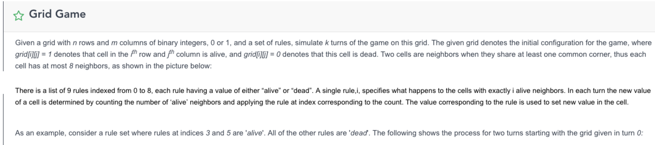

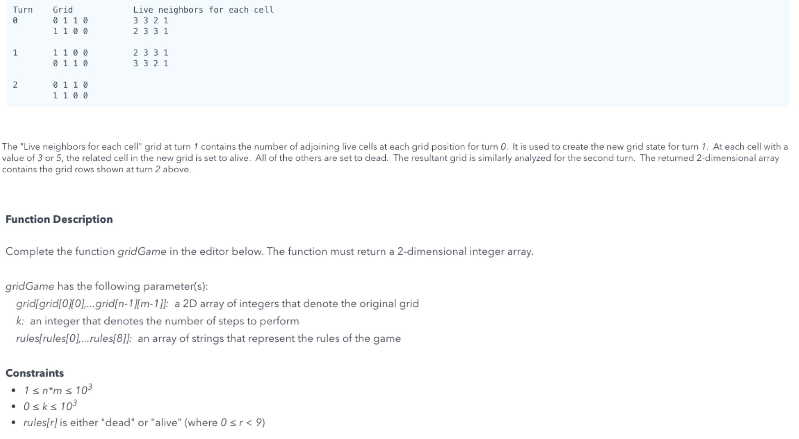

### 思路：

题意是把当前cell邻居的total value当做index在rule里找到对应的“dead”or“alive”，然后改变当前cell的死活。

步骤1：先把rules里的dead和alive转换成array数字

步骤2：创建计算neighbor value的方程

步骤3：根据neighbor value方程的结果，来改变当前cell的数字，循环k次。

### 代码：

public class gg {

private static int[] directionRow = {-1, 0, 1, 1, 1, 0, -1, -1};

private static int[] directionCol = {-1, -1, -1, 0, 1, 1, 1, 0};

public static int[][] gridGame(int[][]grid, int k, String[] rules){

//convert rules to 1(alive) and 0(dead)

int ruleLen = rules.length;

int[] ruleNumber = new int[ruleLen];

for(int i = 0; i < ruleLen; i++){

if(rules[i].equals("alive")){

ruleNumber[i] = 1;

} else {

ruleNumber[i] = 0;

}

//System.out.println(ruleNumber[i]);

}

//update the grid k times

for(int z = 0; z < k; z++){

//do every cell

for(int i = 0; i < grid.length; i++){

for(int j = 0; j < grid[0].length; j++){

int neighborsValue = calNeighbors(grid, i, j);

if(ruleNumber[neighborsValue] == 0){ //dead

grid[i][j] = grid[i][j] == 0 ? 0 : 2;

} else { //alive

grid[i][j] = grid[i][j] == 1 ? 1 : 5;

}

}

}

//update the grid for the current round

for(int t = 0; t < grid.length; t++){

for(int h = 0; h < grid[0].length; h++){

grid[t][h] %=2;

}

}

// 打印

// for(int[] ro : grid){

// for(int item : ro){

// System.out.print(item + " ");

// }

// System.out.println(" ");

// }

// System.out.println(" ");

}

return grid;

}

//calculate neighbors value

public static int calNeighbors(int[][]grid, int r, int c){

int value = 0;

for(int i = 0; i < directionRow.length; i++){

if(r + directionRow[i] < 0 || r + directionRow[i] >= grid.length

|| c + directionCol[i] < 0 || c + directionCol[i] >= grid[0].length) {

continue;

}

if(grid[r + directionRow[i]][c + directionCol[i]] == 1 || grid[r + directionRow[i]][c + directionCol[i]] == 2){

value++;

}

}

return value;

}

public static void main(String[] args){

String[] rules = {"dead", "dead", "dead", "alive", "dead", "alive", "dead", "dead", "dead" };

int[][] grid = { { 0, 1, 1, 0 }, { 1, 1, 0, 0 } };

int[][] result = gridGame(grid, 2, rules);

for (int[] r : result) {

for (int e : r)

System.out.print(e + " ");

System.out.println(" ");

}

}

}

1. A Strange Sorting Problem

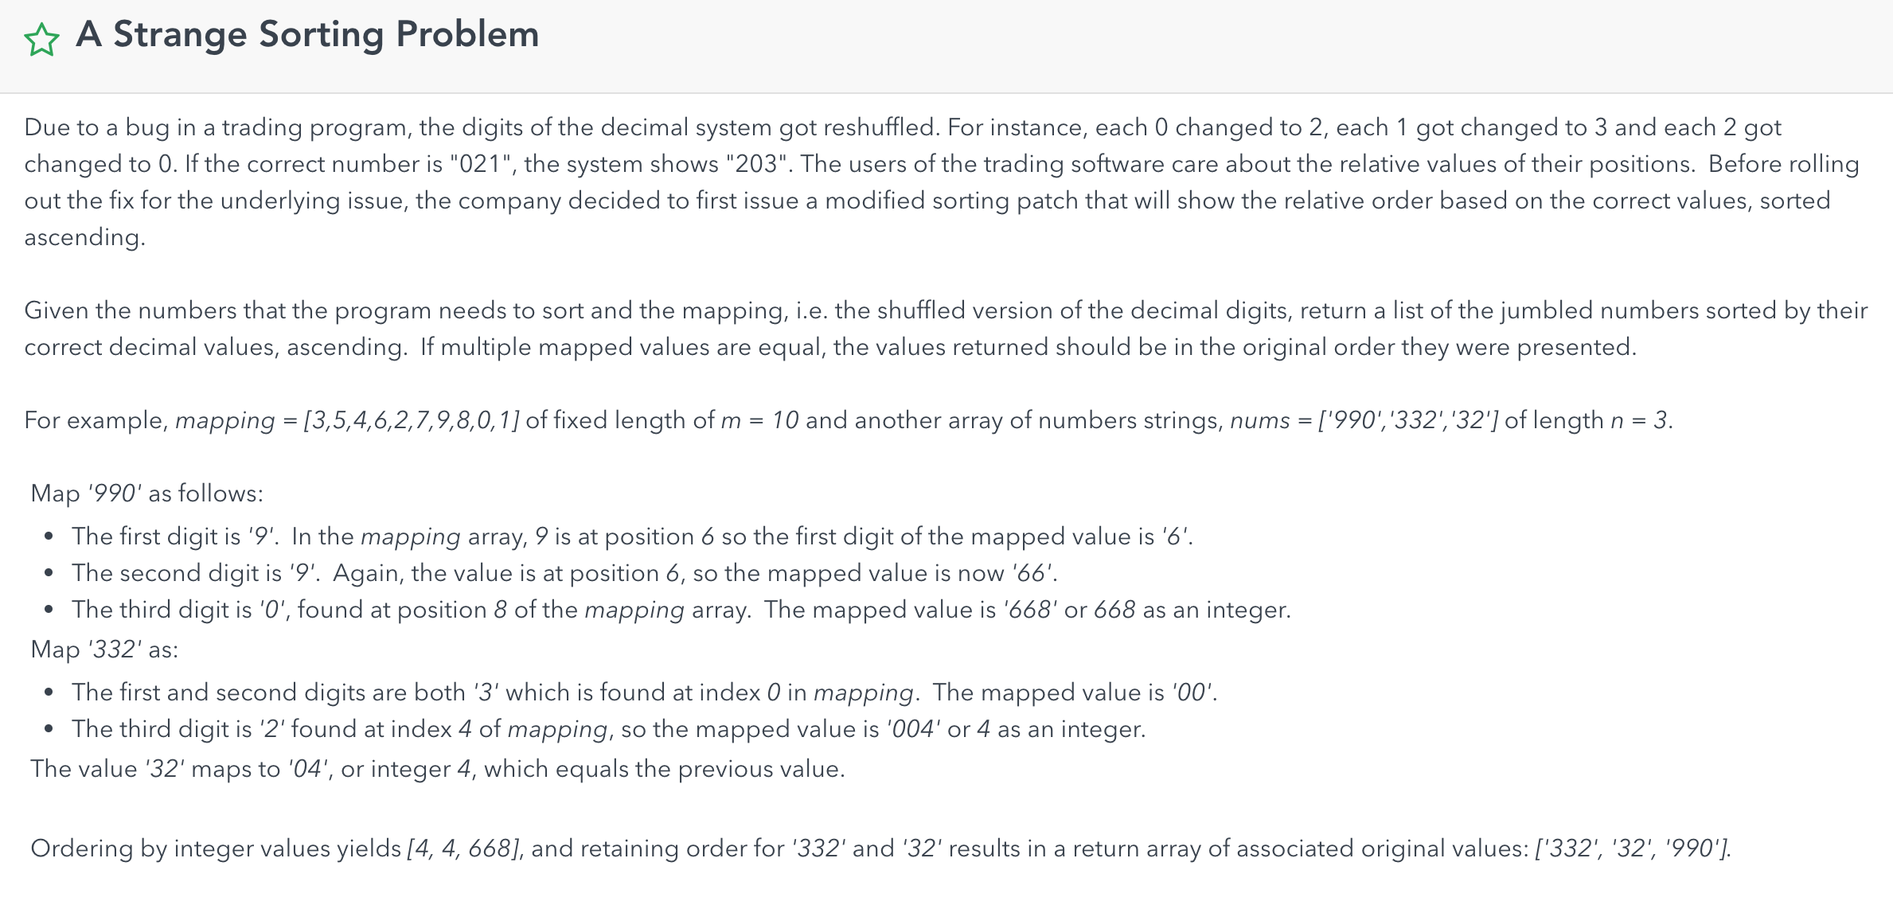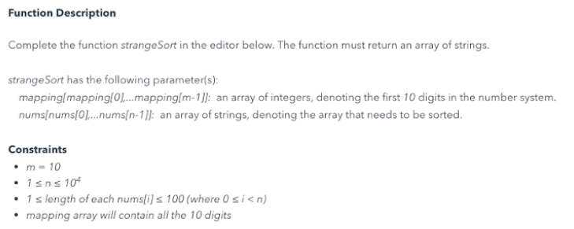

### 思路：把乱的数字的mapping建立好，然后新建一个class，这个class里包括了数字的正确数字，和数字的错误数字，把正确和错误数字都assign给这个类里的data field，然后用comparator来比较这个类里的数字大小，以此完成用正确的数字给错误的数字排序。

### 代码：

import java.util.*;

public class ss {

public static void main(String[] args){

List<String> nums = Arrays.asList("990","332","32");

List<Integer> mapping = Arrays.asList(3,5,4,6,2,7,9,8,0,1);

List<String> output = helper(nums, mapping);

System.out.println(output.toString());

}

static class Container{

public String oldOne;

public String newOne;

}

private static List<String> helper(List<String> nums, List<Integer> mapping){

// number : index

Map<Integer, Integer> lookupMap = new HashMap<>();

List<String> finalResult = new ArrayList<>();

List<Container> newNums = new ArrayList<>();

for(int i = 0; i < mapping.size(); i++){

lookupMap.put(mapping.get(i), i);

}

for(int i = 0; i < nums.size(); i++){

String numsItem = nums.get(i);

StringBuilder sb = new StringBuilder();

for(int j = 0; j < numsItem.length(); j++){

sb.append( (char)('0' + lookupMap.get( (int)(numsItem.charAt(j) - '0') )) );

}

Container container = new Container();

container.oldOne = numsItem;

container.newOne = sb.toString();

//把newNums这个List里装满 新的和旧的nums

newNums.add(container);

}

//sort container

Collections.sort(newNums, new Comparator<Container>() {

@Override

public int compare(Container item1, Container item2){

int num1 = Integer.parseInt(item1.newOne);

int num2 = Integer.parseInt(item2.newOne);

return num1 - num2;

}

});

for(int i = 0; i < nums.size(); i++){

finalResult.add(newNums.get(i).oldOne);

}

return finalResult;

}

}

## Find the Rank

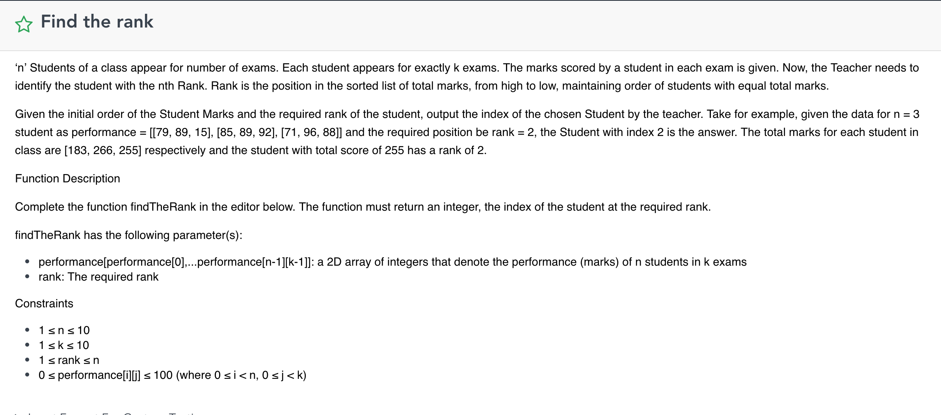

实现的方法是map<int, stack<int>> 使用这个数据结构是为了解决两名同学同分的情况  
建立   [某分数->所有得了该分数的同学的index]的映射  
  
思路如下：题目要求在总共为n位学生中 找从高到低排名第k的同学     
                这个问题可以转化为找从低到高排名第 n-k+1位的同学    
                在同分的情况下输出index小的同学（也就是说同分的情况下index越小的同学排名越高）  
                好了  现在可以利用stack后进先出的性质了 和  map把key从小到大排列的性质   
                直接for (auto a : map)这么遍历 找到的第n-k+1位同学就是结果需要的

### 代码：

//自己写的find the rank的正确代码

import java.util.*;

public class findrank{

static class Student{

int score;

int index;

public Student(int s, int i){

this.score = s;

this.index = i;

}

}

public static int fr(int[][] performance, int rank){

List<Student> list = new ArrayList<>();

for(int i = 0; i < performance.length; i++){

int total = 0;

for(int j = 0; j < performance[i].length; j++) {

total += performance[i][j];

}

list.add(new Student(total, i));

}

//this question needs descending sort, from high to low

//compare(A, B)

//if A > B return 1，把B往前放（前小后大）--> ascending order sort

//if A > B return -1，把A往前放（前大后小）--> descending order sort

Collections.sort(list, new Comparator<Student>(){

@Override

public int compare(Student s1, Student s2){

//if s1.score == s2.score, we need to compare s1.index and s2.index

//smaller index will rank higher

if(s1.score == s2.score){

return s1.index < s2.index ? 1 : -1;

}

return s1.score > s2.score ? -1 : 1;

}

});

return list.get(rank - 1).index;

}

public static void main(String[] args){

int[][] performance = {{1,2,3},{4,5,6},{7,8,9}};

int rank = fr(performance, 3);

System.out.println(rank);

}

}

## 4. Matrix Game

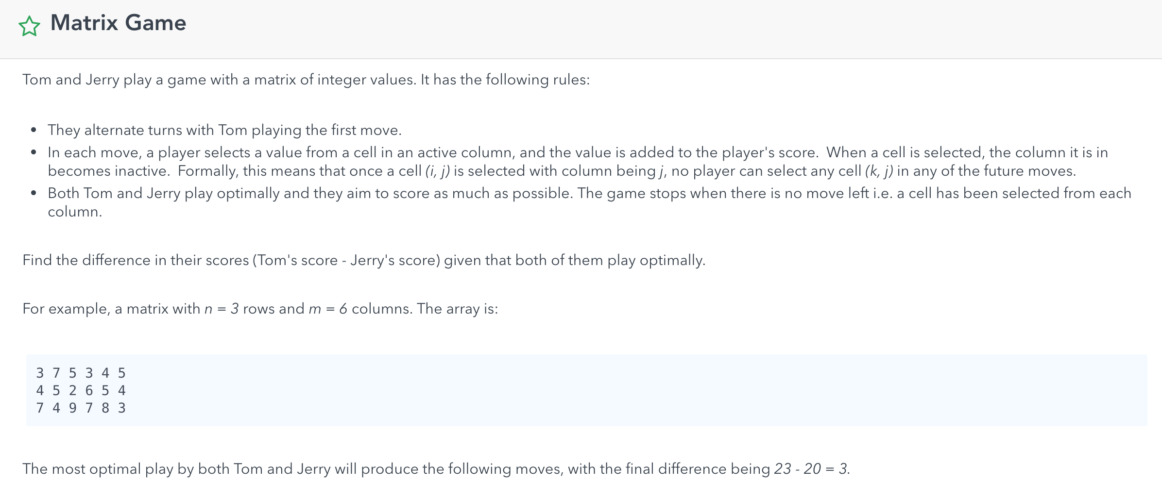

### 思路：基本就是把每列的最大值拉出来， 然后让两个人从大到小拿， 最后return difference

### 代码：

// Matrix Game 自己写的正确的code

import java.util.*;

public class matrixgame {

public static void main(String[] args){

int[][] matrix = {{3,7,5,3,4,5},{4,5,2,6,5,4},{7,4,9,7,8,3}};

int result = 0;

result = matrixGame(matrix);

System.out.println(result);

}

public static int matrixGame(int[][] matrix){

int r = matrix.length;

int c = matrix[0].length;

PriorityQueue<Integer> pq = new PriorityQueue<>(Comparator.reverseOrder());

for(int j = 0; j < c; j++){

int max = Integer.MIN_VALUE;

for(int i = 0; i < r; i++){

max = Math.max(max, matrix[i][j]);

}

pq.add(max);

}

int Tom = 0, Jerry = 0;

int difference = 0;

Boolean tomTurn = true;

while(!pq.isEmpty()){

if(tomTurn) Tom += pq.poll();

else Jerry += pq.poll();

tomTurn = !tomTurn;

}

difference = Tom - Jerry;

return difference;

}

}

1. Maximum Commonaity

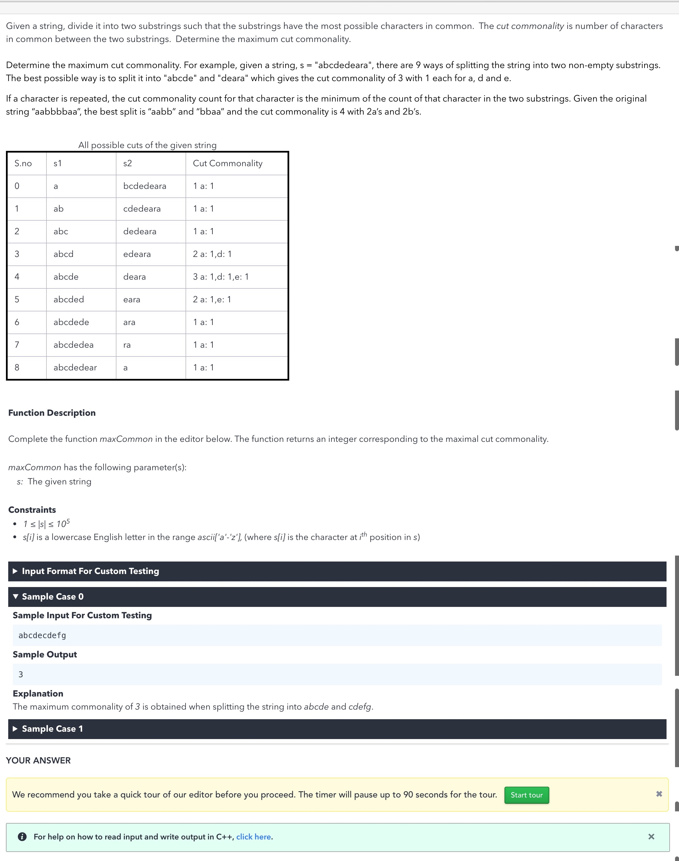

### 代码：

import java.util.HashMap;

import java.util.Map;

//自己写的正确的code

public class maxcut {

public static int maxCommon(String s){

Map<Character, Integer> rightSideMap = new HashMap<>();

for(char c: s.toCharArray()){

rightSideMap.put(c, rightSideMap.getOrDefault(c, 0) + 1);

}

int leftEnd = 0;

int common = 0;

int maxcom = 0;

Map<Character, Integer> leftSideMap = new HashMap<>();

while(leftEnd < s.length()){

char c = s.charAt(leftEnd);

if(leftSideMap.containsKey(c)) common -= Math.min(leftSideMap.get(c), rightSideMap.get(c));

leftSideMap.put(c, leftSideMap.getOrDefault(c, 0) + 1);

if(rightSideMap.get(c) == 1)

rightSideMap.remove(c);

else

rightSideMap.put(c, rightSideMap.get(c) - 1);

if(rightSideMap.containsKey(c) && leftSideMap.containsKey(c))

common += Math.min(leftSideMap.get(c), rightSideMap.get(c));

if(common > maxcom){

maxcom = common;

}

leftEnd++;

}

return maxcom;

}

public static void main(String[] args){

System.out.println(maxCommon("abcdecdefg"));

}

}

## 6. Rotate String

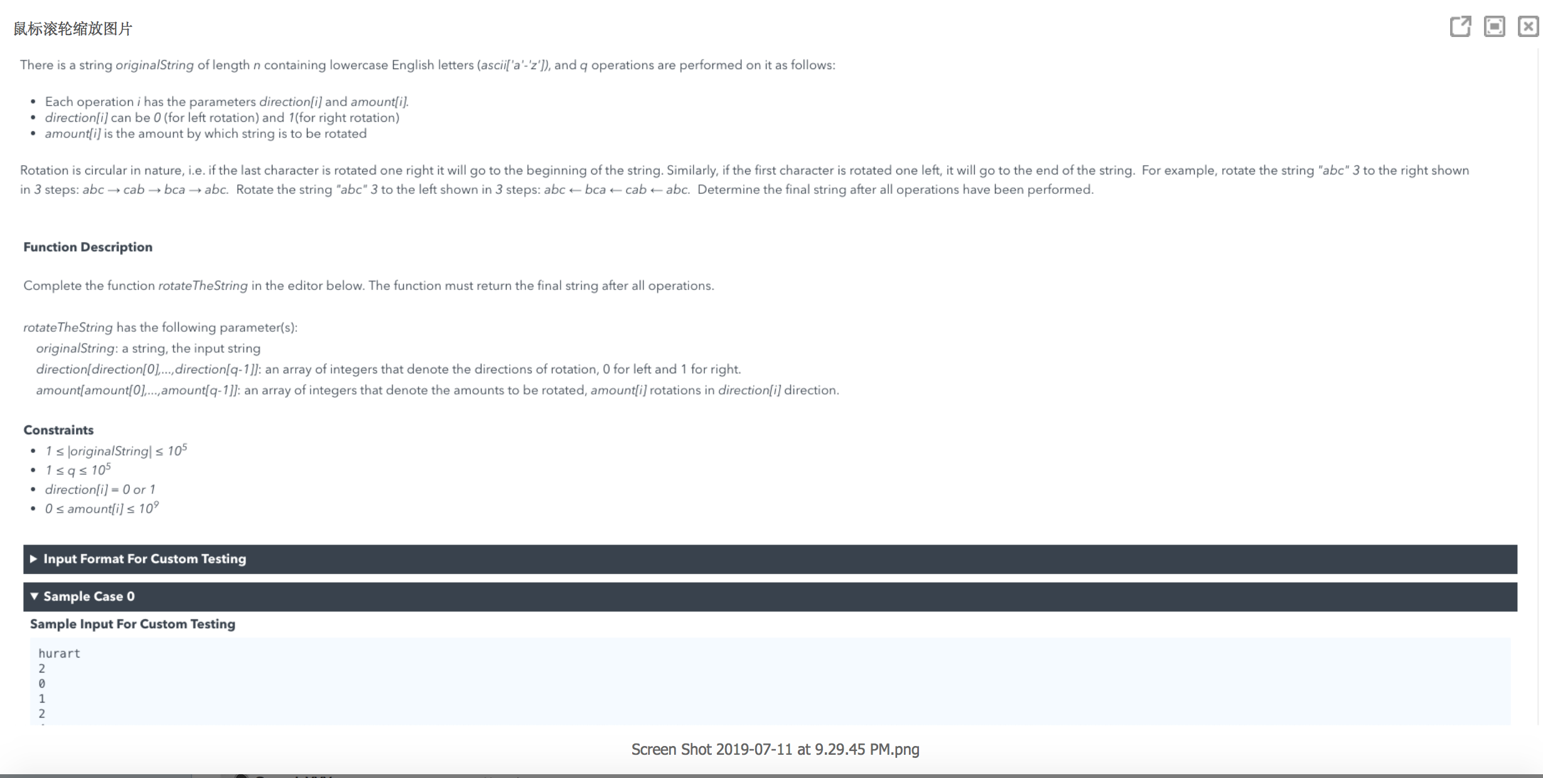

### 代码：

public class rotatestring {

public static void main(String[] args){

String s = "abc";

int[] dir = {0,0,0};

int[] amount = {2,1,1};

System.out.println(rotateTheString(s,dir,amount));

}

public static String rotateTheString(String s, int[] dir, int[] amount){

int len = s.length();

int left = 0, right = 0;

for(int i = 0; i < dir.length; i++){

if(dir[i] == 0) {

left += amount[i]%len;

left %= len;

}

else {

right += amount[i]%len;

right %= len;

}

}

if(left == right) return s;

else if(left > right){

left = left - right;

s += s.substring(0,left);

return s.substring(left);

}

else {

right = right - left;

s = s.substring(len-right) + s;

return s.substring(0,len);

}

}

}

## 7. Share Purchase – leetcode 76



思路：简化为就是找到起码包含A B C各一次的 所有subarray的个数，用sliding windows，O（N）

### 代码：

//自己写的正确的code - share purchase

public class sharepurchase {

public static long sharePurchases(String s){

int[] map = new int[128];

map['A'] = 1;

map['B'] = 1;

map['C'] = 1;

long cnt = 0;

int l = 0, r = 0, counter = 3;

while(r < s.length()){

if(map[s.charAt(r++)]-->0) counter--;

while(counter == 0){

//System.out.println(s.substring(l,r));

cnt += s.length()-r + 1;

if(map[s.charAt(l++)]++==0) counter++;

}

}

return cnt;

}

public static void main(String[] args){

System.out.println(sharePurchases("ABBCZBAC"));

}

}

## 8. Spiral Primes – leetcode 54

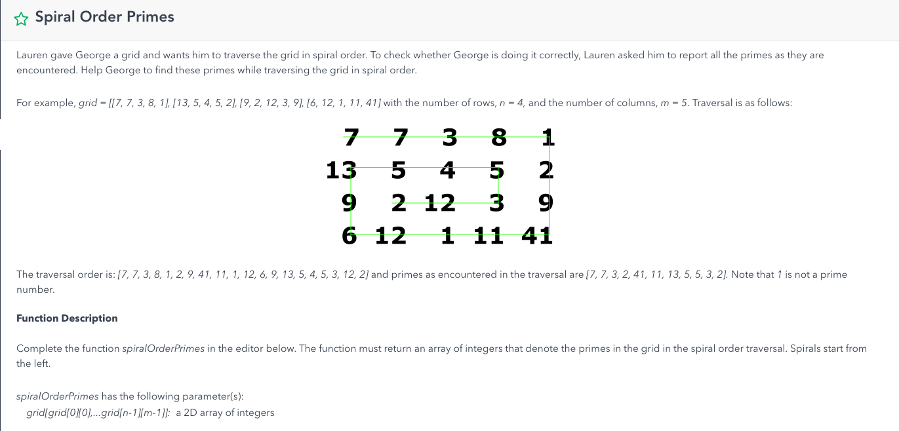

### 代码：

public class spiralmatrix {

public static int maxInteger = 1000000;

public static List<Integer> spiralMatrix(List<List<Integer>> matrix) {

List<Integer> list = new ArrayList<>();

if (matrix == null || matrix.size() == 0)

return list;

// Prime table

boolean[] prime = new boolean[maxInteger];

Arrays.fill(prime, true);

prime[0] = false;

prime[1] = false;

for (int i = 2; i < (int) Math.sqrt(maxInteger) + 1; i++) {

if (prime[i]) {

for (int j = i * i; j < maxInteger; j += i)

prime[j] = false;

}

}

// Iterate Spiral Matrix

int m = matrix.size(), n = matrix.get(0).size();

boolean[][] vis = new boolean[m][n];

int[][] dir = new int[][] { { 0, 1 }, { 1, 0 }, { 0, -1 }, { -1, 0 } };

int i = 0, j = 0, d = 0;

while (!vis[i][j]) {

vis[i][j] = true;

int element = matrix.get(i).get(j);

if (prime[element])

list.add(element);

int nexti = i + dir[d][0], nextj = j + dir[d][1];

if (nexti == m || nextj == n || nexti < 0 || nextj < 0 || vis[nexti][nextj])

d = (d + 1) % 4;

i = i + dir[d][0];

j = j + dir[d][1];

if (i < 0 || i == m || j < 0 || j == n)

break; // for special cases like [[1]]

}

return list;

}

public static void main(String[] args){

}

}

/* Sieve Of Eratosthenes

public static List<Integer> sieveOfEratosthenes(int n) {

boolean prime[] = new boolean[n + 1];

Arrays.fill(prime, true);

for (int p = 2; p * p <= n; p++) {

if (prime[p]) {

for (int i = p * 2; i <= n; i += p) {

prime[i] = false;

}

}

}

List<Integer> primeNumbers = new LinkedList<>();

for (int i = 2; i <= n; i++) {

if (prime[i]) {

primeNumbers.add(i);

}

}

return primeNumbers;

}

*/

## 9. Weekly Stock Price

### 代码：

public class weeklystock {

public static List<String> weeklyStockPrice(int[] dailyPrice){

List<String> list = new ArrayList<>();

if(dailyPrice.length<7) return list;

int len = dailyPrice.length, prefixSum[] = new int[len+1];

//这个地方感觉少了几行代码

// prefixSum[0] = dailyPrice[0];

// for(int i = 1; i < len; i++){

// prefixSum[i] = prefixSum[i-1] + dailyPrice[i]

// }

for(int i = 1; i <= len; i++){

prefixSum[i] = prefixSum[i-1] + dailyPrice[i-1];

}

for(int i = 7; i < prefixSum.length; i++){

double avg = (double)(prefixSum[i]-prefixSum[i-7])/7;

String s = String.format("%.2f",avg);

list.add(s);

}

return list;

}

}

## 10第二小的数

### 代码：

public class secondsmall {

public static void main(String[] args){

Sol s = new Sol();

System.out.println(s.second(new int[] {1,4,2,3,-1}));

}

}

class Sol{

public int second(int[] arr){

// corner case: arr.length < 2 pr == null

int min = Integer.MAX_VALUE;

int second = Integer.MAX_VALUE;

for(int i : arr){

if(i < second){

second = i;

if(i < min){

second = min;

min = i;

}

}

}

// say negative one stands for no secondary small value

return second == Integer.MAX_VALUE ? -1 : second;

}

}